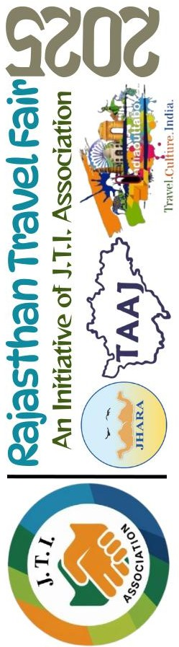

RAJASTHAN TRAVEL FAIR  2025  An Initiative of J. T. I. Association | ABSTRACT  An Event planned by three premier organizations of Jodhpur – Jodhpur Hotels and Restaurants Society (JHARA), The Travel Agent Association of Jodhpur(TAAJ) & India Outtabox Pvt Ltd to feel and celebrate and importantly, for the growth of the Tourism Industry  DATES  September 25 – 29, 2025

The Mission:
- To promote the importance of Travel Agents to the End Customer / Tourists
- To create a bond between Travel Agents across the countries
- To promote Jodhpur Tourism to other state’s Travel Agents.
- To showcase other state’s Tourism to Jodhpur based tourists/travellers
- To promote the travel awareness and impart the travel knowledge among school kids
- Most importantly, to create a strong network of Travel Agents and Hoteliers and together we work towards a bigger mission – Promote Tourism

The Vision:
  - To work towards the growth of Tourism, and growth of Travel Agents & Hoteliers
  - To bring the tourists and travellers to use the service of Travel Agents for their vacations

The Dates: September 25th-29th, 2025 (Thursday – Monday)

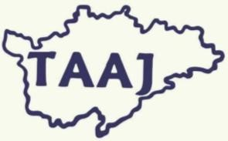

The Team: - The event is hosted under the Association of JHARA, TAAJ & India Outtabox Pvt Ltd. (J T I Association)
The Jodhana Hotels and Restaurants Association (JHARA) have also given their confirmation to partner for this event.

The Travel Agent Association of Jodhpur (TAAJ) will be hosting the event along with us.

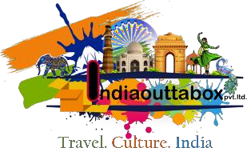
India Outtabox Pvt Ltd a boutique travel agency based in Jodhpur, has proudly served the industry for the past eight years. This year, as a gesture of gratitude and commitment to our industry, we have chosen a meaningful occasion to give back—World Tourism Day, September 27th, 2025..

President | Vice-President | Secretary | Treasurer
VINNY K WILLIAMS | GAJ RAJ SINGH SHEKHAWAT | RAJESH SINGHVI | NARENDRA SINGH
(M) 9660061777 | (M) 9829026858 | (M) 9829027775 | (M) 9829742233

The Event Details: This event will be implemented in two different segments, B2B & B2C. B2B will solve our vision points no. 1, 2 & 3. And B2C will solve our vision points no 4 & 5. Sharing below the detailed plan for both segments:

Segment 1 - B2B Segment
Please read Guest (Travel Agents from other states), and Host (travel agents from Jodhpur)
    - Invites go out to Travel Agents from other states of the country to come and:
      - experience the culture of Jodhpur
      - Showcase their state to Jodhpur people for their next tourism destination
    - Invites go out to Local Travel Agents (Jodhpur) to participate and:
      - Host a guest, giving them a real time experience of Jodhpur tourism
      - Assist them in showcasing their State to local people
    - Every participating host is assigned a participating guest. Host will be responsible to take the guest around the city and give them a local experience. Also, they will work as a team on the event day to promote the Guest’s state tourism to local Jodhpur crowd.
(This will create a bond between host & guest which will continue even after the guests leaves. Both host
& guests will be able to then help each other in promoting and selling each other’s state tourism)

Flow of Events:
    - 25th September, till 5 PM – Guests arrival and check-in followed by Welcome Drinks & Dinner
    - 26th September, till 11 AM - 6 PM – B2B Exhibition opens up for Travel partners
    - 26th September 7PM onwards – Networking Dinner with cultural Program
    - 27th September 11AM onwards – Booths at the venue opens up for the local public. Guests and Host will form a team, showcase the guests stay to the visiting crowd and will try to sell packages to the local public visiting the venue.
    - 27th September 5 PM onwards – “Show Time”
During the “Show Time”, there’ll be some school kid’s performances and competition. More information on this event is shared in the B2C segment.
    - 28th September - 9 AM – 4 PM – Jodhpur Sightseeing where the host will take the guest around Jodhpur to give them an experience of Jodhpur Culture and History
    - 28th September - 6PM -11 PM onwards – Fun activities, contests, competition for the participating hosts & guests along with Drinks & Dinner.
    - 29th September – Post breakfast, check-out & Departure

President | Vice-President | Secretary | Treasurer
VINNY K WILLIAMS | GAJ RAJ SINGH SHEKHAWAT | RAJESH SINGHVI | NARENDRA SINGH
(M) 9660061777 | (M) 9829026858 | (M) 9829027775 | (M) 9829742233

Activities for the Travel Agents/Hoteliers/Exhibitors on Sept 28th 2025:

    - Property visits from the participating Jodhpur Hotels

    - Jodhpur Sightseeing & Cultural Immersion - Their local host will take the guest for Jodhpur sightseeing and help them experience the culture of Rajasthan

    - Quiz Competition (Theme: Rajasthan Travel Fair 2025) – On the basis of their experience of the B2B segment, their sightseeing visit and knowledge gained from the entire 4-day event, there’ll be a quiz program for the participants with handsome rewards for the winners.

    - Souvenir Exchange – All travel agent and hotelier participants visiting the event will bring a Souvenir with them, they will be all be collected and distributed among the other participants on a lucky draw basis.

Segment 2 - B2C Segment
This segment will ensure:
    - Spreading awareness about benefits of booking through Travel Agents
    - Making it easy for local crowd/public to choose the destination for their next holidays
    - Imparting knowledge about travel and required information to school kids & the local public

The Plan:
    - Various Contests for kids and Inter-school Competitions will be announced in July Second week.
    - Marketing of these Contests and Competition will be done during July and August to ensure maximum participation.
    - All the prelims and initial rounds of these contests will be done during the first three weekends of September. Final rounds will be kept on The World Tourism Day, 27th September. These final rounds will ensure the gathering and presence of local crowd for the event.
    - “Show Time” - On the day of the event, September 27th - 5 PM onwards, we’ll have final rounds and announcement of winners along with some performances from kids. The final rounds and few other activities will be scheduled at different timings during the day so that the visiting crowd is divided and they have time in between to visit the Travel Booths.

President | Vice-President | Secretary | Treasurer
VINNY K WILLIAMS | GAJ RAJ SINGH SHEKHAWAT | RAJESH SINGHVI | NARENDRA SINGH
(M) 9660061777 | (M) 9829026858 | (M) 9829027775 | (M) 9829742233

    - In between the final rounds, we’ll have several activities explaining people on the benefits of travelling, benefits of booking through travel agents, various tourist destination and their details.
    - We have also planned few activities for the Parents/local public to get them engaged into the event.
Contest for the Kids:
- Inter School Quiz  - Chess Competition  - Dancing Competition  - Singing Competition | - Painting Contest  - Insta-Reel Contest  - Stand-up Comedian Contest
And many more fun activities…

Target Audience:

B2B Segment – Hotels & Travel Agent | B2C – Local Jodhpur Public
We are expecting a participation of around 100+ travel agents / Hoteliers from across the country hosting a booth at the event and almost the same number from across Rajasthan  visiting/attending the event. | We are expecting a participation of around 700+ kids across all contests from schools all over the city. And almost 20,000+ gathering of parents/teachers/local public of Jodhpur.
We are confident that at the end of the event,
    - there’ll be lot of kids who would have learnt the key things about Travel and Tourism
    - there’ll be lot of Jodhpuris who would have purchased the package for their next vacation
    - and most importantly, Travel Agents from across the country would know what are they going to promote about Rajasthan,
    - and Travel agents from Jodhpur will have direct connects/travel agent friends with local travel agents in other states
This event is not only going to create a bond among entire Tourism industry, but will also offer a lot to our local travellers, a perfect blend of B2B and B2C event.

President | Vice-President | Secretary | Treasurer
VINNY K WILLIAMS | GAJ RAJ SINGH SHEKHAWAT | RAJESH SINGHVI | NARENDRA SINGH
(M) 9660061777 | (M) 9829026858 | (M) 9829027775 | (M) 9829742233

